

**Southern River College**

**PSYCHOLOGY 2021 Task 1**

**Biological Influences Test**

­­­

Student Name ______________________________

Time allowed for this paper

Working time for paper: *60 mins* **60 marks** *6% of course*

1. Dr Savage is running a psychological study which examines the effect a new drug has on memory. She selects ten of her friends to take part in her experiment. She flips a coin to decide which friends she administers the drugs to and which she does not. She administers the drugs by putting into their food when they come over to her house for dinner. She concludes that drug is effective in helping people’s memory as the friends who were administered the drug are able to recall the plot of the film they watched.

a. Define the term sample in context of psychological research. **(1 mark)**

______________________________________________________________________________________________________________________________________________________________  
  
b. Assess whether Dr Savage’s research is experimental or non-experimental. **(3 marks)**

___________________________________________________________________________________________________________________________________________________________________________________________________________________________________________________________________________________________________________________________________________________________________________________________________________

c. Using examples, explain two ethical issues with Dr Savage’s study. **(4 marks)**

_________________________________________________________________________________________________________________________________________________________________________________________________________________________________________________________________________________________________________________________________________________________________________________________________________________________________________________________________________________________________________________________________________________________________________

d. Evaluate whether Dr Savage’s conclusion is valid. **(3 marks**)

___________________________________________________________________________________________________________________________________________________________________________________________________________________________________________________________________________________________________________________________________________________________________________________________________________

2.

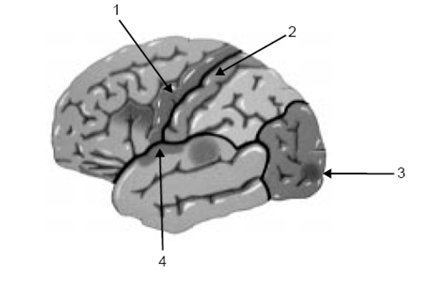

a. Identify all four lobes of the cerebral cortex, as shown above, and outline their function. **(6 marks)**

______________________________________________________________________________________________________________________________________________________________________________________________________________________________________________________________________________________________________________________________________________________________________________________________________________________________________________________________________________________________________________________________________________________________________________________________________________________________________________________________________________________________________________________________________________________________________________________________________________________

b. With reference to an appropriate structure, explain why the limbic system is often referred to as the emotional nervous system. **(2 marks)**

____________________________________________________________________________________________________________________________________________________________________________________________________________________________________________________________________________________________________________________________

d. Identify a structure of the hindbrain, and outline its function. **(3 marks)**

____________________________________________________________________________________________________________________________________________________________________________________________________________________________________________________________________________________________________________________________

3.  
a. Describe the corpus callosum and outline its importance in regards to brain **(2 marks)**

____________________________________________________________________________________________________________________________________________________________________________________________________________________________________________________________________________________________________________________________

b. Dr Quinn has a patient who has damaged the right side of their brain. Explain the types of impairments this patient will have. **(2 marks)**

____________________________________________________________________________________________________________________________________________________________________________________________________________________________________________________________________________________________________________________________

[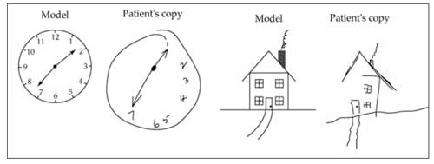](http://www.google.com.au/url?sa=i&source=images&cd=&ved=0CAgQjRw4Ew&url=http://www.joinstick.net/psychology/%E0%B8%AD%E0%B8%B2%E0%B8%81%E0%B8%B2%E0%B8%A3%E0%B8%9A%E0%B8%B2%E0%B8%94%E0%B9%80%E0%B8%88%E0%B9%87%E0%B8%9A%E0%B8%97%E0%B8%B2%E0%B8%87%E0%B8%AA%E0%B8%A1%E0%B8%AD%E0%B8%87-8.html&ei=8hyRVM-cKqbLmAXA44KYCQ&psig=AFQjCNF-QRyq4JQHDg51EKiLhkMuvfCmvg&ust=1418882674762364)

c. Dr Quinn has another patient who has suffered a stroke. This patient is having difficulty recognising faces, and when asked to, he draws the above picture.

Identify what hemisphere of the brain has been damaged. **(1 marks)**

_______________________________________________________________________________

d. With reference to the symptoms, assess which part of the cerebral cortex has been damaged.  **(3 marks)**

____________________________________________________________________________________________________________________________________________________________________________________________________________________________________________________________________________________________________________________________

4.

a. Outline how electroencephalography is used to investigate brain function. **(2 marks)**

____________________________________________________________________________________________________________________________________________________________________________________________________________________________________________________________________________________________________________________________

b. Dr Brennan wants to find out which areas of the brain are activated when are recalling memories; should he use a CAT scan or a PET scan. Explain with reference to the type of images the scanning techniques produce. **(2 marks)**

___________________________________________________________________________________________________________________________________________________________________________________________________________________________________________________________________________________________________________________________________________________________________________________________________________

c. A patient is complaining of headaches and Dr Cruxon thinks it may be a tumour. Describe the form of one brain scanning or external recording device/s she could use could and why. **(3 marks)**

___________________________________________________________________________________________________________________________________________________________________________________________________________________________________________________________________________________________________________________________________________________________________________________________________________

d. Describe another brain imaging technique Dr Cruxon could use for this patient and evaluate it in comparison to the technique mentioned in the question above, with reference to the strengths and limitations of both. **(5 marks)**

_________________________________________________________________________________________________________________________________________________________________________________________________________________________________________________________________________________________________________________________________________________________________________________________________________________________________________________________________________________________________________________________________________________________________________

e. Identify one case study that has been influential in investigating brain function and assess its contribution to this area of research. **(4 marks)**

________________________________________________________________________________________________________________________________________________________________________________________________________________________________________________________________________________________________________________________________________________________________________________________________________________________________________________________________________________________________________________________________________________________________________________________________________________________________________________________

f. Outline one limitation associated with case studies as a method for investigating brain function case studies. **(2 marks)**

_____________________________________________________________________________________________________________________________________________________________________________________________________________________________________________

5.

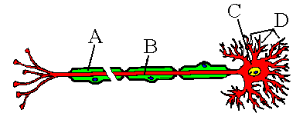

Identify the four structures labelled on the diagram above, and their functions. **(6 marks)**

________________________________________________________________________________________________________________________________________________________________________________________________________________________________________________________________________________________________________________________________________________________________________________________________________________________________________________________________________________________________________________________________________________________________________________________________________________________________________________________

**END OF TEST**